CHALLENGING THE DIGITAL NATIVES WITH WEB QUESTS IN TEACHING AREA AND CULTURE STUDIES
Maxim Ilyahov
Russian Federation
Maxim.ilyahov@yandex.ru
Abstract
Digital natives hold a considerable advantage against traditional educators. With information competence formed as early as high school, these audiences are good at shortcutting the traditional learning curve, leaving a massive learning potential untapped. The paper describes an experiment held at Lomonosov Moscow State University, aimed at maximizing the use of student potential in the course of Area Studies. The aim of the experiment is to test whether a series of web quests could be used to develop broad cross-disciplinary expertise in geography, cultures, economics and politics, while still ensuring compliance with traditional curriculum requirements. Experiment subjects were 23 students, aged 17–20, majoring in foreign languages and area studies (2nd year of the 4-year Bachelorate).
In the course of the experiment, designed and implemented were three quizzes that incorporated a number of custom web-quiz-based tasks. Follow-up performance was measured following the quiz to test whether completing a web quest created broad, systematic and sustainable expertise. The aim was to identify the most successful web quest designs and a possible successful design pattern.
The results revealed a pattern: successful challenging web quiz designs were highly structured, had strict formal requirements and were based on multiple retrievals and rewrites of the Web content. Key to student engagement were game-like mechanics, electivity and open-ended questions at the core of the tests. The paper explains these principles in-depth.
Main design and implementation obstacles were: student unfamiliarity with the design, lack of attention in reading the task and insufficient pre-task activities, overwhelming workload for marking certain test types. The paper expands on ways to overcome these obstacles.
Keywords: digital natives, web quests, pedagogical design, Wikipedia

Introduction: design requirements of a more challenging curriculum
The new generation of students, born in the 1980-s onwards, bear a significant technological advantage against their 1960-s—1970-s-born educators. With digital devices and wireless connectivity solutions widely available, these “Digital Natives” have all the knowledge in the world at their fingertips, and know how to access it in the classroom, during the quiz, as they write their essays, during exams and more. They find answers, read up, collaborate on answers and even automate manual tasks with the help of today’s Web tools—all in a quest to spend less time learning and more time doing what’s exciting and important to them. The case of digital natives has been studied extensively in recent years, including calls to rethink education with digital natives in mind [1]. Understanding digital natives and adapting to their ways and practices is the focus of many works, including the brilliant in-depth analysis of digital natives’ roles and behaviours made by J. Palfrey [2] in 2008. Evidence suggests that the digital natives’ understanding of rational information behaviour is different from that of the previous generations. It requires rethinking the learning environment and adapting it. However, while this call sounds promising, actual changes are hard to bring about in tight curriculum-driven institutions.
To make the change, educators have already started designing their curricula with extensive web use in mind. This shift in didactic design raised awareness of many challenges, including development of information competence in students, the question of integrity and sustainability of web-enabled curricula, maintaining standards and managing learning groups, “flattening” of the classroom and more. While the key question remains: How do you help them start learning things, not Googling things?

The Problem: Systematically Unchallenging Curricula
We at Faculty of Foreign Languages, Lomonosov Moscow State University, of all ICT-driven challenges, have been most concerned with sustainability and integrity of the web-acquired knowledge, as indicated by our lead researchers in the field: E. Solovova, S. Titova, A. Filatova and M. Verbitskaya. With our fundamental approach to education, our concerns on retaining the basis have been more than realistic with more of the emerging digital natives enrolling into our programs.
With extensive cultural expertise required to take our flagship courses, our students have consistently relied on Wikipedia and other popular shortcut resources to compensate for low cultural awareness in class and during exams. We felt that, with more wiki-sourced texts and ideas emerging in our students’ works, the students made no effort to learn beyond the formal minimal requirements. As a result, very little value was put into the knowledge gained during the course, shallow expertise generated during the course and integrity of skills and knowledge was put to risk.
We identified the problem as lack of real intellectual challenge to students of area and culture studies. We felt there was a need of more demanding and engaging teaching tools that allowed to tap into the unused learning potential. As a traditional learning establishment, we rely on proven and traditional curricula, so we were first looking for practical tools and teacher-end solutions, rather than fundamentally different approaches propagated by today’s scholars. We were looking for tools to help rectify the situation and build upon the experience and traditions we already have.

The Solution: Innovative In-Course Tasks And Tests
Our solution was to address the in-course testing grid. Bound to formal requirements and timing and set on a regular basis, in-course checkpoints serve as a reliable platform to engage and challenge the otherwise unmotivated digital natives. Our task was to design and test the tasks for these checkpoints and reveal the principles behind successful test design.
Current Web Quest efforts and studies, e.g. those of web quest pioneer Bernie Dodge [3], E. Halat [4], M. Gaskill [5] and others, and are highly valuable in the preparation for our task. However many of them are still highly focused on the early stages of web-quest design that do not account for competitive web-enabled student environments. Other side of Web Quest research, as seen in works of C. D. Maddux & R. Cummings [6][7], attack web quests for being insufficiently researched, providing unpredictable and unsustainable results and for being a fad more than a teaching tool. This approach to web quests resonates with our concerns. In many ways, current Web Quest approaches are indeed perceived as an experimenting platform, not a platform to deliver sustainable results, with design principles being rather liberal, and most focus set on the technical part of web-quest design and implementation. Since we were looking for a stricter, more sustainable framework, we felt a need to develop a set of our own requirements to guide the web quest design process.

Requirements for Test Design
EXTENSIVE, ‘BEYOND-WIKIPEDIA,’ WEB USE—the tasks needed to be designed to prevent students from using current Wikipedia materials as one-stop answers to the questions. The questions had to be focused on items not featured in the Wikipedia articles or require beyond-Wikipedia research. As we realized we could not practically prevent students from going to Wikipedia for both content and references, we needed to design with beyond-wiki complexity and depth.
‘BEYOND-COPY-AND-PASTE’ INTERACTION—the tasks needed involve analysis, systematization, reordering, criticism and other ways to interact with content to answer the question. It was critical to design the tasks that could not be answered by merely copying and pasting relevant text from a Web source.
REALISTIC COMPLEXITY AND CONFORMITY TO GENERAL CURRICULUM—the tasks, while being in-depth and beyond Wikipedia, still needed to be realistic in terms of complexity and had to reflect the general course requirements as provisioned by the curriculum. Since most course requirements only identify broad areas of expertise, we saw a possibility to design tests that would strike balance between complexity and conformity.
PER-STUDENT VARIABILITY WHILE REMAINING EASY TO CHECK—the tasks needed to be designed to prevent students from collaborating on answers when taking the test outside the classroom, while remaining easy to be checked by instructors or, where possible, automated systems.
STUDENT-SIDE VARIABILITY—following the principles of student-centered approach, we required our tasks to have room for electivity, while ensuring integrity of educational content. The students had to be faced with a choice of tasks, so approaching each task was meaningful and willing.
With design guidelines set forth, we were able to build a series of mid-term (checkpoint) quizzes and subject a group of students to the tests in order to determine the efficiency of the tests and task types, as described in the following sections.

Experiment: iterative design and testing
The experiment was held at the Faculty of Foreign Languages and Area Studies, Lomonosov Moscow State University in Moscow, Russian Federation. Subjects to experiment were 20 students of Region Studies department, specializing in North America. The students were in their 3rd semester of the 8-semester bachelor course. The experiment was held within the ‘Introduction to American Regional Studies’ discipline—an entry-level course that gets the students acquainted with the profession of a regionalist.
The course curriculum covers the historical and cultural regions of the USA on a per-region basis. Students learn about the geographical, historical, industrial and economical, social and cultural peculiarities of the region. The course spans two semesters during which students cover all regions of the USA. The course also includes a strong linguistic component covering a wide range of related English vocabulary that would be required to continue in-depth American studies in semesters 5—8.
The experiment was set up to challenge students with checkpoint quizzes every month (one test for every three classes). The quizzes had to cover the issues discussed during the previous three classes and add an extra class’ worth of related material as a self-study task.

First Iteration: Traditional Test to Verify the Digital Divide
To test the ideas set forth in the Introduction to this paper (those related to the information advantage of the digital natives in the classroom), the first test was designed to identify the gap between the traditional curriculum and the digital natives’ capabilities when connected. A traditional testing framework as provisioned by the original course curriculum was used to design and deliver the test. The students received print-out forms of the quiz tasks featuring:
- multiple-choice questions covering the basics,
- definition tasks covering major new concepts,
- date-event-matching tasks for the period in question,
- open-ended questions for in-depth reasoning (e.g., “What is the main argument in Columbus’s letter to the King and Queen of Spain?”)
- and open-ended lists for complex event analysis (e.g. “Main reasons of the Independence War:..”).
The students had 90 minutes to complete 20 tasks, each task rated individually to make up the total of 100 points.
The students received no specific instructions whether they were allowed to use their smartphones and tablet computers for reference. The instructor remained in the class during the quiz, observing student behaviour and tracking the remaining time. The instructor didn’t interfere with student’s using the digital tools.
The students perceived the instructor’s presence as a call to avoid overt cheating and ventured into covering up: 15 out of 20 students were noted of stealthily referencing the Web. The remaining 5 students appeared to be avoiding digital tools.
The results were marked and matched for copies and plagiarism. The average score for the work was 80,88% with the following distribution:
- 3 works scored over 90%, best result — 94%;
- 12 works—between 76 and 89%%, average score—83,21%;
- 5 works—under 75%, worst result—64%.
The subsequent matching of the 5 underperforming works to students revealed that 4 students in this group used no digital reference to help them through the test.
The follow-up class focused on checking consistency of Checkpoint Test 1 performance. The instructor asked questions from the checkpoint test and evaluated the students’ participation, mastery of the subject and knowledge of facts on a scale of 1 to 10. The results of the performance test revealed no consistent connection between web-assisted quiz performance (works that scored 75% and above) and follow-up performance in class, as seen in fig. 1. Students displayed mediocre performance across the board, displaying insufficient expertise in the subject, fragmentary knowledge and lack of understanding of the in-depth details, which was clearly contrary to their original performance in the Checkpoint Test. The follow-up performance of the non-web-assisted students was consistent with their original performance.
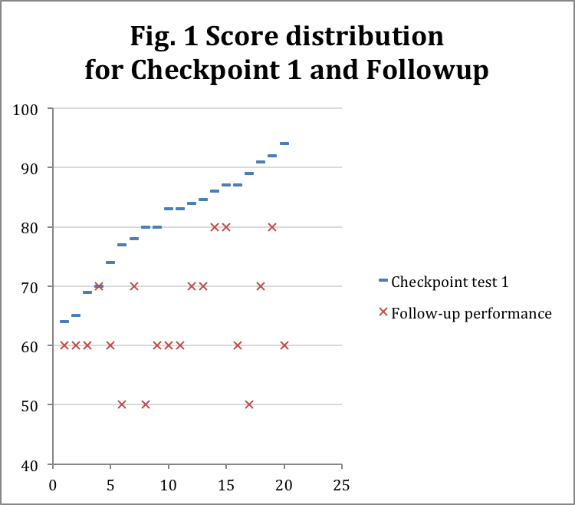
The checking of works revealed that all students who sought assistance with the web used Wikipedia as their primary source of information, as displayed by recurring phrases and ideas in open-ended questions, open-ended lists and definitions.
In the course of the first iteration, we concluded that:
- digital tools do in fact produce an advantage in academic performance of between 25 and 55 %% within the traditional testing framework;
- the advantage in question bears a temporary character and is not sustainable outside the web-assisted environment, thereby requires additional efforts for internalisation and activation.
We proceeded to the second iteration to create a more engaging design and produce more sustainable and consistent web-based knowledge.

Second Iteration: Open-End-Based Digital Test
For the second iteration, a new quiz and a new evaluation framework was developed. It accounted for the design principles set forth for the experiment (explained in the Introduction section to this paper).
The second quiz was designed as a set of elective mini-essay tasks. The students were offered 5 pairs of topics for mini-essays. Out of each pair they could select one topic, so at the end they were set with a task to write 5 mini-essays. Each essay had a limitation on total word count, a requirement to list the links to documents used to support the argument. Links to Wikipedia were not allowed.
A pair of mini-essay topics reflected a subject in the curriculum and essentially covered the same material. A student was in liberty to choose one of the approaches to the subject, e. g.:
“Write a short essay answering one of the following questions. Use no more than 200 words. Provide links to support your argument. Do not use links to Wikipedia.
- Who was the mayor of the New York City when the attacks of 9/11 took place? What did he or she do to help the city rebound from the attack? How did the life of the New Yorkers and all Americans change after 9/11?
- Explain the political situation in the USA when the attacks of 9/11 took place. What changed in the lives of Americans after the attack? What global changes happened because of the attacks?”
Selection between two questions in a pair was introduced to make the process more personal and engaging. We assumed students would pay more attention and give more effort to answering a question they chose themselves.
The mini-essay topics were designed to prevent direct copying and pasting of materials from Wikipedia (ensuring that no direct search query could find the whole Wikipedia-based answer), while the word count limitations were designed to prevent copying and pasting from more verbose and authoritative sources. We assumed that such limitations would ensure more engagement with the digital content, force students to read and analyze materials, outline main ideas and search for facts in various contexts, ensuring more interaction and activation.
The students took the quiz digitally outside class within 36-hours upon task release. All students managed to complete the task within the given time.
The checking framework was redesigned to accommodate the new quiz and disclosed in the opening section of the quiz. Each essay was graded on a rubrics-type criteria basis. The criteria included vocabulary, grammar and style, mastery of the subject, logic, pragmatics (to what extent the question has been answered in the essay) and research efforts. To stimulate going beyond the minimal requirements, the grading system had a provision for outstanding efforts. This meant the tutor could grade above the upper threshold, should a student make outstanding effort in selecting vocabulary, perfecting style, researching the subject etc.
Similar to the first iteration, the quizzes were corrected and marked and a follow-up session was held to check integrity and sustainability of knowledge. The marking of works showed:
- All students made efforts to at least edit the web-copied material;
- All essays were unique (no to-the-letter copies);
- 17 students completely re-wrote the material of at least three mini-essays out of five (no traces of copying web materials);
- 9 students copied the same extracts from the web and left them relatively intact;
- 12 students failed to meet the word limit on at least one mini-essay;
- For the total of 100 essays, 62 original links were used, including 15 links to Wikipedia-hosted materials.
On the whole, student performance during the test can be characterized as more involved, engaged, passionate and personal. However, we were still looking at a collection of rewrites of web articles, without much analysis, outstanding creativity or desire to profoundly study the subject. The students performed more responsibly, but still treated most of the work formally. We felt there was more potential to be uncovered in the third iteration.
The score distribution (fig. 2) displays more consistency and overall better student performance following the quiz.
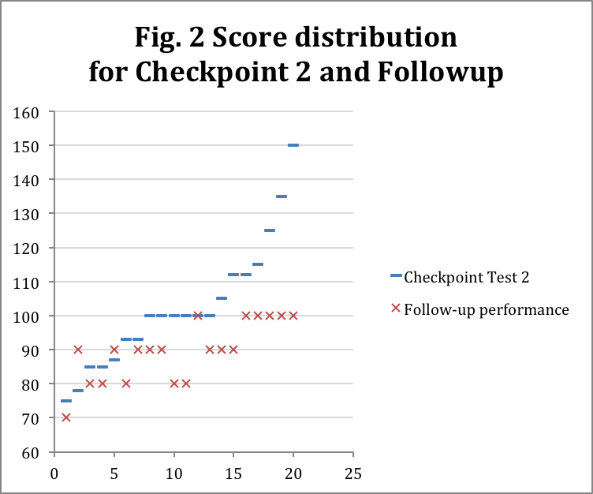
The chart (fig. 2) displays high across-the-board performance during the follow-up class and a generally better performance by students who took extra time and effort to complete one or more tasks.
Marking and checking the works proved to be a challenge, since we had to check 100 mini-essays worth over 30,000 words in total. And while the rubrics system was helpful, the all-open-ended design was far too time-consuming on the checking stage.
In the course of the second iteration we concluded that:
- Electivity and provision for outstanding achievement stimulate involvement and help produce better sustainability in a web-based quiz;
- Open-ended questions with word count limit alone do not automatically ensure better engagement; More design efforts are required to maximize the student potential.
We proceded into the third iteration to perfect test designs and optimize the checking frameowork.

Third Iteration: Testing With Game Mechanics
Our aim for the third iteration was to summarize the experience we’d had on the previous iterations, attempt to eliminate earlier problems and perfect earlier solutions.
Our main concerns included:
- Copying and pasting of learning materials without proper processing, analysis or editing;
- Possible collaboration on formalized tasks and materials;
- Insufficient engagement with tests and formal treatment of tasks;
- Overly laborious marking process.

Task Types
A new set of quiz tasks was developed to resolve the concerns. The tasks included:
- TWITTER DEFINITION: Define or explain the following words and expressions in under 140 characters (incl. spaces)—aimed at directing students to rewrite the materials found on the web or specifically search for less verbose definitions. Entries are clustered to cover all or most subjects of the course, each cluster presented as a separate task.
- RECOVER THE TABLE: Fill the spaces in the table with dates, facts and names—The table chronologically featured key events in the US history of the given period and some key events for the same period in Russia. The table featured the following columns: century (a merged column for a set of events), date, event, country, what happened, key stakeholders, key participants and country. The task required dozens of queries into Wikipedia in search for targeted facts, dates and names. Adding events from the history of Russia added an additional grounding of the events in the American history with that of Russia. This was aimed ad producing a broader and more integrated engagement with world history. The table is a single task. In a digital environment, the table could be checked automatically.
- FACT-FINDER: Answer each questions in 5 words or less and provide links to support your answer. Do not link to Wikipedia—Students answer short fact-based questions, e.g. Which state is home to the USA’s oldest university?, Which state of the USA has the largest Amish population?. The questions do not necessarily need have a single correct answer: the answers can vary based on different sources, which, in given circumstances, is never critical. Questions may be stated as definitions, so students need to provide the word being defined. Entries are clustered to cover all or most subjects of the course, each cluster presented as a separate task. In a digital environment, the task could be checked automatically.
- EXPLAIN THE DIFFERENCE: explain the difference between the following concepts, using no more than 60 words for every triplet and 40 words for every pair—The students are asked to explore the difference between closely related concepts that appear in pairs or triplets, e.g.: farm, plantation, kolkhoz; agricultural society, industrial society, post-industrial society; the war in Afghanistan, the war in Iraq; the Soviet presence in Afghanistan, the US presence in Afghanistan. The key in this task is to present concepts not widely explored on the web and connect them with similar realities in Russia. Although the students might find ready-made explanations on the web, the word limit will serve as the vehicle to rewrite the answers and provide deeper engagement. Each pair or triplet is presented as a separate task.
- CLOSED GROUPED LISTS—the students are asked to list factors, reasons or components of an event or concept in a grouped fashion. The list has a limited number of groups (group titles left blank) and might have limited number of entries per group. Each list has a strict word limit for list items (e.g. between 2 and 5 words). Students need to analyze the material to regroup the entries. E.g., for the list of the causes of the American Civil War, a list of reasons should be narrowed down to three untitled groups (possible group name answers: economy, politics, slavery; state-related, union-related, international). Every list is presented as a separate task.

Task Variations
In a bid to prevent students from collaborating on tasks, a task variation mechanism was built into the test design. The core idea of the mechanism is to vary the questions in a multi-question tasks by:
- rephrasing the questions,
- adding and removing questions and tasks,
- shifting questions between tasks (i.e., moving a question on a topic from one type of task to another, e.g. from Explain the Difference to Twitter Definition),
- focusing or broadening questions,
- altering the question set in a long-list task (e.g., Twitter Definition or Recover the Table).
Using these simple techniques, we created 5 original quizzes and 5 more similar ones (at least 50% similarity), producing the total of 10 original tests. With this many test variants, students are unlikely to venture into collaboration.
The approach required us to create tasks with at least 20% in excess and spend extra time to reshuffle the tasks. It also complicated delivery, however, we were willing to face the complications to provide a richer and more challenging testing environment. Also, since our plans included transitioning the testing framework into a digital environment, we realized that the task variations mechanism would be a fully automated system.

Scoring Framework
To further influence the student engagement, we decided to take electivity to a new level and introduce a non-restrictive score-based framework for a section of the test.
THE NON-RESTRICTIVE SCORE-BASED FRAMEWORK requires students to set their own scoring goals for and willingly select the tasks to fulfill their score expectations. There are no limitations as to how many and which tasks need to be completed in the test—the students are free to select any tasks they wish within their goal expectations.
At the beginning of the test or section, students are informed of the maximum score they could get by correctly completing all tasks from the test/section. The maximum score is above borderline pass score by at least 70% and above Grade-A achievement by 20-50%. The score space is divided into ranges with descriptive characteristics, e.g. failed (0—51), junior (52—75), middle (76—100), executive (101—125). The ranges need to be related to academic stages and have a formal backing, e.g. being a fail range, a borderline fail range, a ‘good’ and ‘excellent’ ranges and preferably a ‘beyond excellent’ range. Also, the ranges need to be characteristic of people, possessing certain qualities that students might aspire to or associate with (as in the job titles example).
Students are asked to think which score range they would like to reach in their work. In that way, students may identify their achievement expectations and associate themselves with the level of expertise they would like to possess. The students do not need to pronounce their choices, but since the question is asked, students identify automatically.
The delivery of the score expectations section was designed to be separate from the testing process and occur before the testing. The students could define their expectations before they set to the test, not set the expectations in hindsight. We aimed to make sure students understood the whole process ahead of the test.
Once the expectations were set forth, the students received the tests. Each task in the test indicated a score that students would receive if the task was completed correctly. Advanced tasks had higher scores, while simpler ones were less valuable. Since most tasks were clusters featuring questions that covered all key subjects of the tested course segment, there was no problem of integrity and thoroughness.
Typically, such framework would contain two or three major tasks that provide for minimal achievement standards (in our case, in a 100—125-point score space, two major tasks were worth 25 points, and venturing above the 51-point Fail line required one extra task). The remaining tasks would have difficulty-based distribution of scores, more difficult ones being more valuable.
The students were asked to select the tasks they preferred in the test, complete them and sum up the score to match their expectations. The students were free to select any tasks they preferred. This could include avoiding the major minimal-achievement tasks in favor of the more challenging tasks.
The framework required us to design questions in excess by at least 25% of the desired maximum to provide for outstanding achievement and advanced complexity.

Iteration results
The test built with all the abovementioned principles, was held in December 2011. The test was distributed digitally by e-mailing the test variants to students. Prior to the test distribution, in a class, we instructed the students on the test principles, task types, scoring system and score expectations. The students had 3 weekdays and a weekend to complete and submit the test. The pre-marking score analysis displayed the students’ rather high expectations of their works bearing little to no connection with their actual performance (fig.3)
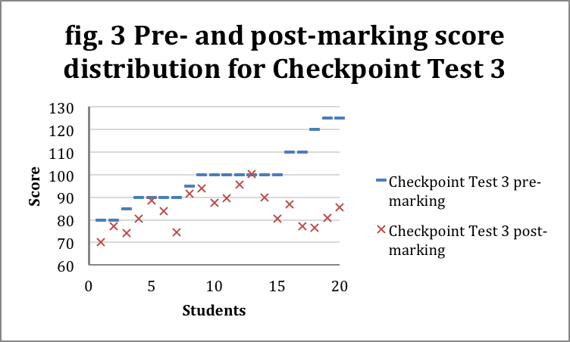
The distribution suggests that most students were aiming for the top quarter of the score space (76—100%) with only 5 students aiming for extra achievement and only 2 students (10%) aspiring to be top-achievers (125%). The chart suggests that those aspiring higher were actually those to perform worse than their average-aspiring peers.
The marking of works revealed:
- Despite prior explanation, most students didn’t grasp the concept of Twitter Defintion. 12 students completely failed the Twitter Rewrite task for not complying with the 140-character rule, all losing 20 points. In follow-up talks, they claimed that the task was new and they did not expect the 140-character rules to be serious.
- The remaining 8 students had no problem completing the Twitter Definition task, although making some mistakes along the way, and 1 student being extraordinarily careful and going lenghts to comply with the rules.
- 10 students had singular tasks failed because they used Wikipedia as their only reference, which was a violation of the rules.
- No copy-and-paste material was detected in works neither through format analysis nor through plagiarism checks. All materials (except the Twitter Rewrite tasks) were rewritten and reorganized.
- No collaboration on works was detected, since no patterns in mistakes or wordings could be traced across the test variants.
- Of 10 students who ventured into the closed-list task, only 5 managed to keep within the closed-list format. The remaining 5 students expanded the lists, making little to no effort to properly reorganize the ideas.
The marking itself was far less time-consuming, as most tasks required short answers.
The follow-up performance assessment was a surprising success. All students, even the ones failing to consistently deliver throughout the course, were engaged and actively participated, while delivering correct and thorough answers to the questions included in the test. This included the top-aspiring students who underperformed during the test after failing to meet task requirements. Although they hadn’t scored, they had still studied the subject and put in work to answering the question. The comparative follow-up distribution across all tests is displayed in fig. 4
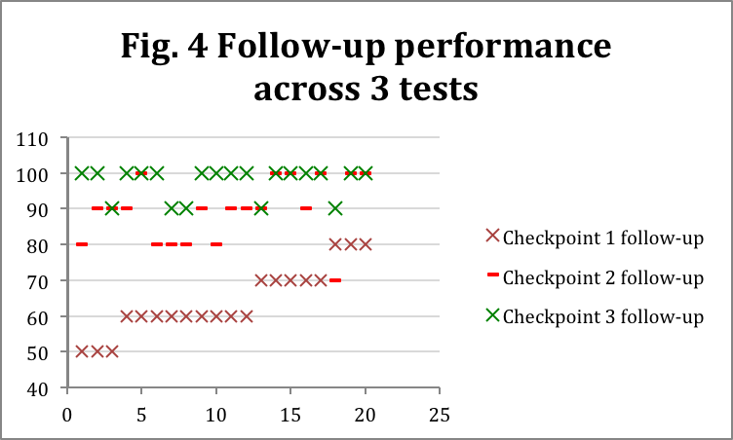
The chart displays an overall lift of engagement, integrity and consistency in knowledge with all students, including the low-performing group.
The issues we were concerned with after the third iteration were:
- Insufficient clarity in task requirements (especially the new kinds of tasks),
- Test delivery was too flexible to ensure compliance with formal task requirements.
We assume these issues could be resolved by transferring the testing practice to an interactive digital platform that would automatically alert and remind students of the test requirements.

Experiment Results and Design Guidelines
In the course of the experiment we discovered that web quests did in fact engage the digital natives to a far greater extent than traditional testing. Through flexible and web-oriented test designs we were able to maximize student participation, engagement and integrity of knowledge despite students relying on the Web. We found ways to circumvent harmful copy-and-paste practices, quiz collaboration schemes and to go beyond Wikipedia for knowledge, reference, sources and materials for analysis.
Ahead of the experiment, we defined a set of design requirements (explained in-depth in sect. 1):
- Extensive, ‘Beyond-Wikipedia’ use of the Web
- Beyond Copy-and-Paste interaction
- Realistic complexity and conformity to the curriculum
- Electivity (student-side variability) and per-student variability
We designed a series of tests and defined a set of guidelines to guide the future design process. The following key principles are worth mentioning:
- Strict formalization of tasks through word count limits, tables, closed lists—prevent direct copying and pasting from the web and require analysis, rewrites, regrouping etc.
- Open-ended questions at the core of the tasks—refrain from using multiple-choice tasks, instead use formalized open-ended tasks.
- Prooflinking as a requirement—required students to provide web links to support their answer, do not accept Wikipedia links.
- Engaging game mechanics through non-restrictive task selection, point-based performance and characteristic ranges of test scores that students could positively identify with.
- Provision for outstanding achievement—allow students to go the extra mile and provide the means and scoring space to do so.
- Linking with local / native / familiar realities—ask students to co-analyze, compare or contrast the studied realities with the realities already familiar to them.
Through the experiment, we have designed a series of successful types of tasks, including:
- Mini-essays with criteria-based grading: highly engaging, while hard to mark—explained in sect. 2.2
- Table recovery: multi-factor event analysis through filling gaps in the table. Global and foreign events linked with national / local events.
- Fact-finder with beyond-Wikipedia tasks—allows for honing of search skills and better engagement with the learning material.
- Comparisons—when linked with local realities, allows for unprecedented and highly engaging content analysis and reasoning.
Some of the less successful test designs with great potential:
- Twitter Definition (Twitter Rewrite)—defining a term in 140 characters or less is the ultimate exercise in concise critical thinking and original rewriting. Extensive explanation and additional practice required for students to master the format of the task. Potential mass violation of requirements if not explained and trained properly.
- Closed lists requiring regrouping and critical analysis—i.e., reasons or consequences of a historic event,—requires careful design with room for open-ended performance and extensive explanation and practice.
Our research will continue in Spring 2012 seeking to transfer and test current findings in an interactive digital environment and design new kinds of tasks.
REFERENCES
- Bennett S., Maton K., Kervin L. The ‘digital natives’ debate: A critical review of the evidence. British Journal of Educational Technology 39 (5), September 2008, pp. 775–786
- Palfrey J. (2008) Born Digital: understanding the first generation of digital natives. Basic Books.
- Dodge, B. (2001). FOCUS: Five Rules for Writing a Great WebQuest. Learn- ing and Leading with Technology, 28(8), pp. 6—9.
- Halat E. (2008) A Good Teaching Technique: WebQuests. The Clearing House: A Journal of Educational Strategies, Issues and Ideas 81(3), pp. 109—112.
- Gaskill, M., McNulty, A., & Brooks, D. W. (2006). Learning from WebQuests. Journal of Science Education & Technology, 15(2), pp. 133—136.
- Maddux, C., & Cummings, R. (2004). Fad, fashion, and the weak role of theory and research in information technology in education. Journal of Technology and Teacher Education, 12(4), pp. 511—533.
- Maddux, C.D., & Cummings, R. (2007). WebQuests: Are they developmentally appropriate? Educational Forum, 71(2), pp. 117—127.

