Anna Knysh
"Popular culture is the way of life in which and by which most people in any society live.
In a democracy like the United States,
it is the voice of the people–
their likes and dislikes –
that form the lifeblood of daily existence,
of a way of life."
Ray Browne

Why Is American Pop Culture the Most Popular One in the World?
It goes without saying that the American pop culture takes the dominant position in the modern world. We listen to American music, watch American movies, wear American clothes, eat American food and the American style is spreading more and more. We cannot imagine our life without American products any more. No McDonald’s, no Coca-Cola, no Adidas and Nike, no Hollywood movies, no Michael Jackson, Madonna, Lady Gaga and Justin Bieber – without all of these our modern mass culture would be changed drastically. Why is it so that the American culture became the dominant one in the modern world?
First of all, the spread of the mass culture depends on the economy – how much money is invested into this or that kind of culture, how much it is developed. American mass culture is invested a lot of money every year and it is aimed at making a profit. Mass culture is for the most of the people so these investments are very profitable.
Secondly, we live in the time of globalization. Pop culture is the aspect that undergoes the process of globalization most of all. It doesn’t matter where this or that product was produced, it can be found in almost every country in the world. As far as mass culture is concerned, it is the kind of culture that moves on in the world very fast. A song composed in any place of the planet and uploaded to the internet appears in millions of other places in several minutes. Globalization and technologies play a very important role in the development of the global mass culture and transfer of cultural objects all over the world.
Thirdly, the scale of pop culture of the USA is so enormous that it became the predominant pop culture in the world. Every year Hollywood movie studios make more than five hundred movies.
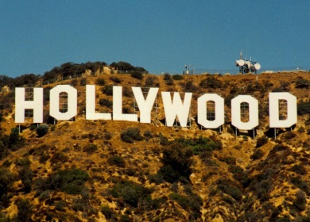
Hollywood is the center of the world’s cinema industry. It includes twenty studios known all over the world, e.g. “20th century Fox”, “Paramount Pictures”. “Warner Brothers”, “Walt Disney Studios” and others. No cinema studio is so popular as the Hollywood studios. Scores of well-known actors work here: Johnny Depp, Angelina Jolie, Brad Pitt, Nicolas Cage, Leonardo Di Caprio, Jim Carrey, Tom Cruise, Cameron Diaz, Nathalie Portman, Monica Belucci, Meryl Streep and many others.
A lot of music styles appeared in the USA. Ragtime, country, jazz, r&b, soul, rap, hip-hop, beatbox, techno, funk are among them. Syncopated, or "ragged," rhythm of ragtime developed into different forms and transformed into elements of jazz. Elements of jazz such as polyrhythms and the swung note transformed into elements of r&b which is extremely popular nowadays all over the world. The most popular artists of r&b are Beyoncé, Mariah Carey, Craig David, Fergie, Keri Hilson, Whitney Houston, Alicia Keys, Leona Lewis, Jennifer Lopez, Madcon, Ne-Yo, Nelly, Usher and many others.
Hip-hop music is a part of hip-hop subculture which includes not only music, but also rapping, beatboxing, hip-hop dancing, MCing, DJing and also graffiti writing. Hip-hop subculture appeared in the USA and spread to every corner of the world. Now there is a little decline in its popularity, but it still plays a very important role in the world’s music and culture. The most popular hip-hop musicians are The Black Eyed Peas, Kanye West, Eminem, 50 cent, Kid Cudi and others. In addition to that, hip-hop music includes also reggaeton music. It is the form of hip-hop music which roots in Latinoamerican and Caribbean music. It is also very popular in different countries.

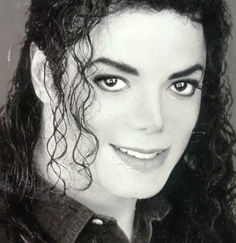
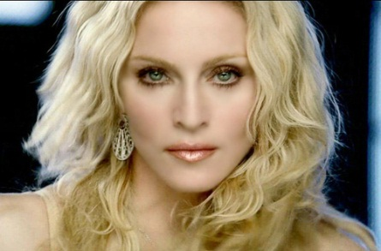
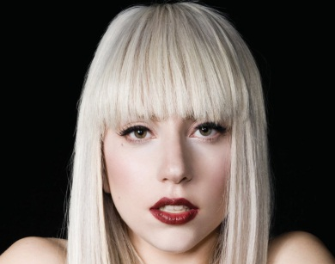
Modern pop music includes different artists and different kind of music and songs. The king of pop music Michael Jackson is the most famous American pop artist ever. He is often referred to as King of Pop or MJ. Throughout his career Michael Jackson transformed the art of music and paved the way to modern pop music. Madonna is another American cult pop artist. She is recognized as “the world's top-selling female recording artist of all time” by the Guinness World Records. Madonna is considered as one of the most influential and greatest figures in music. But these days Lady Gaga is starting to replace her in the pop music world. Lady Gaga is recognized for her color ful, diverse and unconventional contributions to the industry of pop music. She makes flamboyant and exceptional performances; she is also famous for her fashion. All of these people are cult figures in the world’s music and they are Americans. MTV is the most popular and the most famous music channel in the world. It has a great influence on the world’s music industry and the pop culture itself. To sum up, American pop music is now unsurpassed by any of the countries in the world.
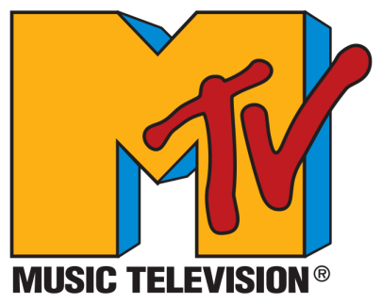
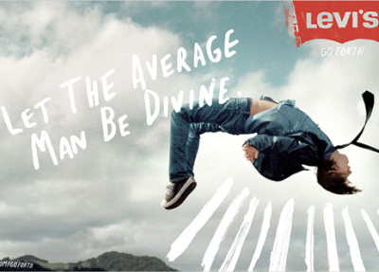

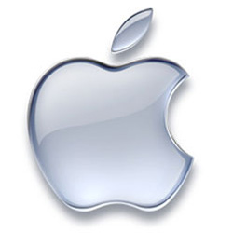
As far as fashion is concerned, America is not the first country in the world. But it gave the world jeans – a piece of clothes that almost everyone has and wears. Blue jeans were popularized in 1850s by Levi Strauss which is now the name of the most famous jeans trademark. Levi’s jeans is actually one of those things considered truly American in the world. On the whole, American style is often associated with cowboy hats, leather motorcycle jackets, boots and jeans. As well as jeans, T-shirts also appeared in America and now are worn by the whole world.
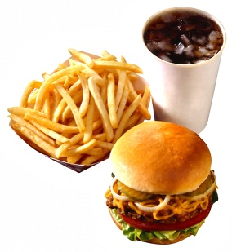
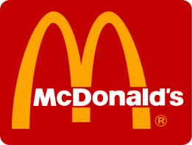
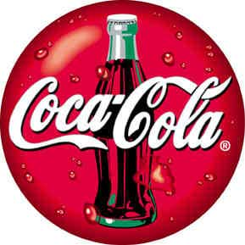
The last point I’d like to develop is American food and how and why it spread all over the world. When we think about American food, we often mean fast food. Burgers and French fries are considered to be traditional American food. Undoubtedly, the most popular fast food restaurant network is McDonald’s. It is spread all over the world nowadays and its popularity doesn’t decrease year after year and new restaurants in new cities are opened. McDonald’s became so popular all over the world because it was the first fast food restaurant and the idea was truly unique. Despite nowadays there are a lot of different fast food restaurants like Burger King, McDonald’s still is the most famous and the most popular restaurant network of this kind. Coca-Cola is another American cult trademark. Introduced in 1886, it spread all over the world and now is sold in more than 200 countries. The drink is well-known and still very popular.
The last decade showed the great increase of popularity of American products. Apple is the company that produces computers, mobile phones and other electronics. Apple products are extremely popular nowadays all over the world and the company itself is the absolute leader in its category. No need to say how many Iphones are there in different countries now, including Russia. Apple is considered to be the sign of prestige.
There can be no doubt that American pop culture is now the predominant culture in the world and it influences other countries and their cultures. At the age of globalization we can say that American culture forms and transforms the modern world’s pop culture, with its music and movie industry, food and fashion. American style and American way of life are now not only American, but become internationally spread. Investments into pop culture provide it with profit, internet, technologies and mass media transfer American pop culture into other countries, and what used to be American mass culture becomes international.

Work cited
- http://www.americanpopularculture.com
- http://culturalpolitics.net/popular_culture
- http://www.webster.edu/~garyford/class_materials/MEDC%206000%20-%20Rebecca%20Osborn%20Thesis-SP2-06.pdf
- http://www.brianscollier.com/classreadings/american_pop_culture_and_ed.pdf
- American Pop. Popular Culture Decade By Decade. Volume 1. 1900-1929. Edited by Bob Batchelor

