Is the United States "a melting pot" or "a mosaic"?
(Gaifutdinov Ruslan)

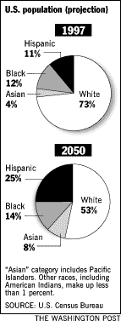
The United States today is a huge laboratory in which probably the most interesting changes of the time are under way. As any other developed country, the USA faces a demographic challenge, but the States are different in a way. The country has been in need for recurring injections of “fresh blood” all over its history in contrast to the European states, which did not experience any hardships of the kind until recently. So people have been coming to “the land of promise” in search for a better life since the very Columbus’ discovery. And what is now a country with a population of over 290 million people is said to be either a uniquely melted American people (a melting pot) or a happy union of multiple nations (a cultural mosaic) or even a highly explosive conglomeration. Forming a clear concept of what it really is, constitutes the aim of this paper.
First of all, initial statistics and a few basic premises should be mentioned. As shown in the chart taken from “The Washington Post” website, in 1997 non-Hispanic Whites comprised slightly less than three quarters of the population. The biggest minority was that of Blacks, closely followed by Hispanics. Asian Americans represented the smallest minority past 1 percent barrier. By 2050 demographers predict a decrease in the white population to a comparatively humble half, whereas Hispanics will constitute a quarter of the inhabitants. Blacks and Asians taken together will make up almost a quarter, as well. Such a striking change, which has not happened ever before, will take place within a bit less than 50 years.
No doubt, the Americans at the helm have been thinking it over in order to work out a solution for the most urgent all-time problem – power. Who will rule the country when white Americans comprise say 25% of the whole population? The principles of democracy stipulate that the people and only the people is to govern the country. But then another question arises: “Are the Whites, being the founders and the creators of the new land, ready to become a minority?”
It looks as if they are not, because of the “melting pot” concept they introduced. Over all the history the best way for a nation to stay alive was swallowing up both friendly and hostile nations without distinction in a melting pot of a powerful civilization. Byzantium, for instance, was taken over by not so numerous Greeks because of their marvelous culture and their captivating language. Other peoples simply wanted to be a part of this prominent nation and readily jumped into the pot.
The situation in the United States is quite similar, though aggravated by racial issues, as well. Furthermore, some nations’ of the Third World have gone through a demographic boom since 1950s, which is a signal of a civilization reaching its fullest flower. The main question here is whether the WASPs (White Anglo-Saxon Protestants) will continue playing their pacemaker role.
Turning to answering the question in the heading of this paper, there seem to be no better foundation for judgement than statistics. Statistics is a simple and explicit proof that the United States of America are a mosaic at best. Needless to say that both “melting pot” and “mosaic” are positive terms, i.e. they express a peaceful state of the people living in the country. In the first case, they prefer peaceful intermarriage, in the second one, a peaceful life together and celebrating diversity. Both terms lack a color of all the anger and bloodshed impressed on the history of the land and the contemporary culture, as if anything negative concerning interracial communication simply does not exist. Apparently, Americans are optimists, but if the ancients were right having supposed that we do not possess things until we name them, Americans are not yet masters of the problem.
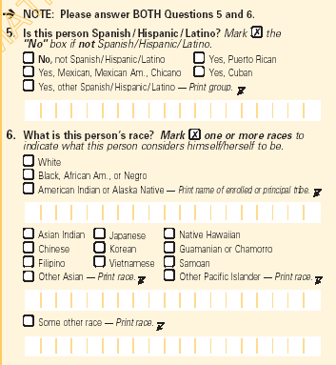
The latest Decennial Census taken in the year 2000 was different from its predecessors in the way that it collected detailed information about ethnicity. The form allowed people to tick as many racial or ethnic groups as they liked. The part of the form concerning the issues of race and ethnicity reprinted below, asked first of all whether a person is Hispanic, to single out the number of people belonging to this distinct part of the white race represented in the States. After that the very question about race comes. The possibility of ticking all the races of one’s ancestors was only restrained by the single box “Some other race” which implies printing only one race which is not included in the list given.

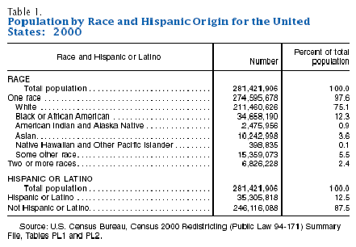
The results of the census were quite surprising for a country having a reputation of a melting pot. Only 2.4 percent of the respondents in 2000 claimed they were multiracial. Factors like the novelty of the form, the fact that people did not have a direct access to filling out the form (traditionally a person in charge comes to you and helps with reporting all the necessary data) might have diminished the number of those out of the melting pot. Actually, a research called “Dimensions of self identification among multiracial and multiethnic respondents in survey interviews” conducted by a number of qualified researchers showed that “respondent's racial identification varies considerably across question formats” [underlined by me] (even the wording of the questions seems to be important) but it also showed that “persons of mixed heritage prefer a racial identification question that provides them, at a minimum, with the opportunity to acknowledge their multi-cultural background. In addition, many respondents also expressed the desire to identify each of the specific groups that constitute their racial/ethnic background.” All in all, 2.4 percent of multiracial people is too little for a country to be called a melting pot.
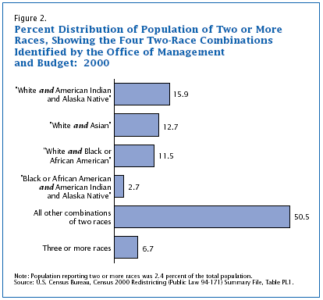
The developments in the USA are of tremendous interest for the other great countries poring over the “big brother” and what is happening to him. The European Union, Canada, Russia and other major parts of the world all envy China its rich human resources and follow carefully the way the USA tackles this crucial issue. At the moment the only superpower is quite prosperous and successful but what happens next is a great mystery.
What really unites the American people is its economy and politics. Those out of the economy and/or having no access to power, naturally conflict with the system. It is hard to imagine a well-educated and well-to-do African American, for instance, who would live in a ghetto and preach racial intolerance or even hatred. Actually the concepts of a “melting pot” or a “mosaic” are a part of American political system, to be more precise, its ideology which is defined in the Merriam-Webster dictionary as “the integrated assertions, theories and aims that constitute a sociopolitical program”.
Any state’s main mission is to maintain a united society, because only joining hands with each other people become stronger. A strong society is also the aim of the American state. This idea was clearly conveyed by President Clinton in his brilliant speech called “The United States: A Nation of Diversity and Promise”. To quote William Booth, a Washington Post staff writer, “ It [racial segregation] is a phenomenon sometimes difficult to measure, but not observe. Houses of worship remain, as the Rev. Martin Luther King Jr. described it three decades ago, among the most segregated institutions in America, not just by race but also ethnicity. At high school cafeterias, the second and third generation children of immigrants clump together in cliques defined by where their parents or grandparents were born. There are television sitcoms, talk shows and movies that are considered black or white, Latino or Asian. At a place like the law school of the University of California at Los Angeles, which has about 1,000 students, there are separate student associations for blacks, Latinos and Asians with their own law review journals.”
To sum up, the future of the United States is unclear, but it will definitely unite its people due to a strong economy and political system. They may label it either a “melting pot” or a “mosaic” or anything else, but the American nation will live as long as the underlying uniting power exists and prospers.

References

- U.S. Census Bureau, Overview of race and Hispanic Origin http://www.census.gov/prod/2001pubs/c2kbr01-1.pdf

- U.S. Census Bureau, Dimensions of self identification among multiracial and multiethnic respondents in survey interviews www.census.gov/prod/2/gen/96arc/iiiajohn.pdf

- The Washington Post, America’s racial and ethnic divides; One nation, indivisible: is it history?
http://www.washingtonpost.com/wpsrv/national/longterm/meltingpot/melt0222.htm

- The United States: A nation of diversity and promise by Bill Clinton , President of the United States http://usinfo.state.gov/journals/itsv/0699/ijse/clin.htm#top

- The Merriam-Webser online dictionary http://www.m-w.com

- Stanfield Rochelle L. , The Blending of the United States http://usinfo.state.gov/journals/itsv/0699/ijse/stanfld.htm

The Washington Post, America’s racial and ethnic divides; “One nation, indivisible: is it history?”

